If you like

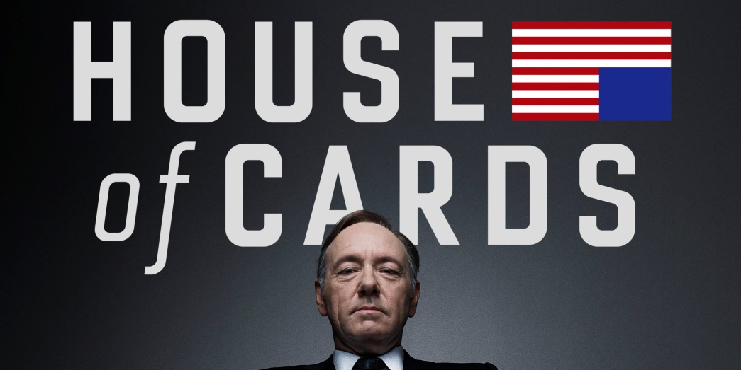

investigate these..

Deer Park Public Library
44 Lake Avenue, Deer Park
(631) 586-3000
www.deerparklibrary.org

House of Cards by Michael Dobbs
A dark tale of greed, corruption, and unquenchable ambition, House of Cards reveals that no matter the country, politics, intrigue and passion reign in the corridors of power.

The Prince by Niccolo Machiavelli
Described both as a practical rule-book containing timeless precepts for the diplomat and as a handbook of evil, this work of great originality--based on first-hand experience--provides a remarkably uncompromising picture of the true nature of power.

I, Claudius by Robert Graves
The emperor Claudius tells of his life during the reigns of Augustus, Tiberius, and Caligula and the events that led to his rise to power in a classic novel reconstructing ancient Rome.

All the President’s Men by Carl Bernstein & Bob Woodward
The two Washington Post reporters present the inside story of their inquiry into the persons involved in the Watergate scandal.

Wolf Hall by Hilary Mantel
Assuming the power recently lost by the disgraced Cardinal Wolsey, Thomas Cromwell counsels a mercurial Henry VIII on the latter's efforts to marry Anne Boleyn against the wishes of Rome, a successful endeavor that comes with a dangerous price.

Team of Rivals: the Political Genius of Abraham Lincoln
by Doris Kearns Goodwin
An analysis of Abraham Lincoln's political talents identifies the character strengths and abilities that enabled his successful election, in an account that also describes how he used the same abilities to rally former opponents in winning the Civil War.

The Talented Mr. Ripley by Patricia Highsmith
Three classic crime novels by the award-winning mistress of suspense fiction chronicle the deadly adventures and sinister exploits of the inimitable Tom Ripley, a psychopath and genius who will do anything to achieve his goals.

All the King’s Men by Robert Penn Warren
Willie Stark's obsession with political power leads to the ultimate corruption of his gubernatorial administration.

The Dwarf by Par Lagerkvist
The Swedish novelist's profound concern about social problems is demonstrated in the actions of a dwarf whose devotion to the Prince brings inevitable disaster.

Autumn of the Patriarch by Gabriel Garcia Marquez
The discovery of a South American dictator's rotting corpse in the deserted tangle of his crumbling palace prompts a search through his past and a colorful chronicle of his progression from popular, beloved, unafraid ruler to isolated, frightened despot.

The Last Thing He Wanted by Joan Didion
During a trip to Florida, Elena McMahon, a Washington Post reporter estranged from her powerful West Coast husband, finds herself caught up in her father's mysterious dealings, global intrigues involving high-level diplomats, arms trafficking, conspiracies, and assassinations.

Watergate by Thomas Mallon
A retelling of the Watergate scandal from the perspectives of seven of its perpetrators and investigators illuminates the drama and high comedy of the Nixon presidency.

